Algebra 3-4 Name: _______________________
1.6 Worksheet Block: ______

Solve each problem. Check your solutions.

1. 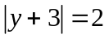 2. 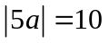 3. 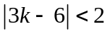

4. 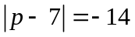 5. 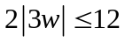 6. 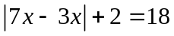

7. 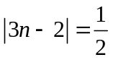 8. 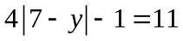 9. 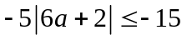

10. 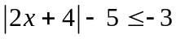 11. 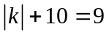 12. 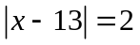

13. 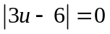 14. 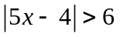 15. 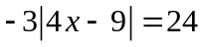

16. 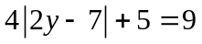 17. 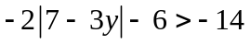 18. 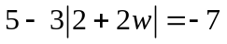

19. Some say that to brew an excellent cup of coffee, you must have a brewing temperature of no more than 200°F, plus or minus five degrees. Write and solve an inequality describing the maximum and minimum brewing temperatures for an excellent cup of coffee.

20. A thermometer comes with a guarantee that the stated temperature differs from the actual temperature by no more than 1.5 degrees Fahrenheit. Write and solve an equation to find the minimum and maximum actual temperatures when the thermometer states that the temperature is 87.4 degrees Fahrenheit.

